**CMPS 312 – Mobile Application Development Final Practical Exam – 4 December 2023 (duration 2h)**

|  |  |
| --- | --- |
| Student Name (Student ID) |  |

**Task Overview:**

1. Sync the cmps312-lab repository and copy the **Final Exam** folder to your GitHub repo, which contains the base project named **PizzaPal** and with all necessary dependencies and the testing sheet.
2. Implement a **PizzaPal** Ordering app that allows users to add pizzas for orders. Manage the app data in an SQLite database using Room Library.

**Implementation Tasks:**

1. **Entity-Relations: [10]** Create two Entity classes, Order and Pizza, each with proper annotations as outlined in Figure 1. Ensure that the IDs are auto assigned by the database. Add foreign key annotations with cascade delete and update on the appropriate entity.

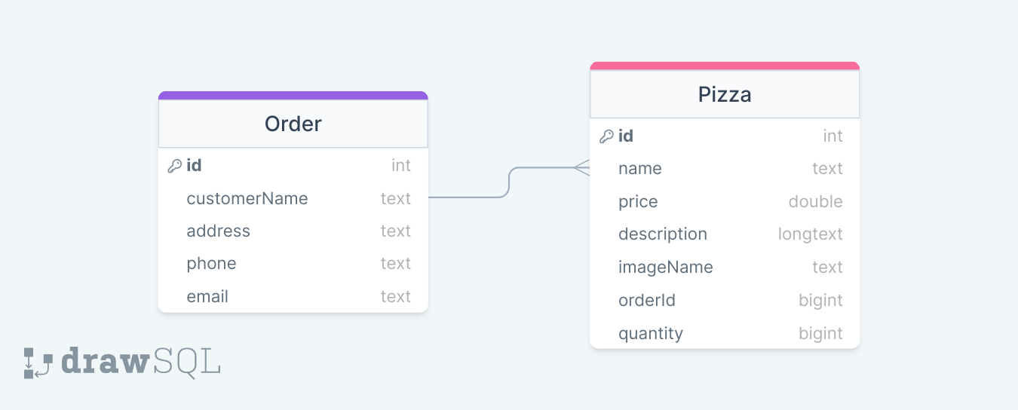

*Figure 1. Product Review Entity-Relations*

1. **PizzaPalDao Interface and PizzaPalDatabase [30]:** Create a the database class and the PizzaPalDao Interface with necessary functions and annotations to allow users to:

* Add a new Order
* Get all orders
* Delete an order and all associated Pizzas
* Add a new Pizza for an order
* Get all Pizza orders for a specific order given orderId
* Update an order’s Pizza

1. **PizzaPalRepository [5]:** Implement the PizzaPalRepository with all necessary methods listed above.
2. **PizzaPalViewModel [20]:** Create a PizzaPalViewModel to serve as an intermediary between the UI and the repository. The ViewModel should:

* Manage the interaction between the UI and the repository for order and pizza data.
* Provide Flows and Observable data to observe changes in the underlying data.
* Handle user inputs and interactions, ensuring proper validation and data integrity.

1. **App UI and Navigation [35]:**

* 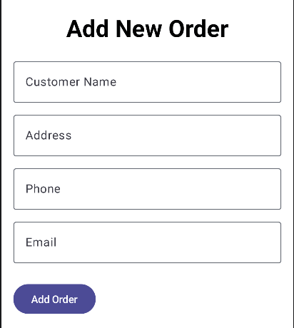Clicking on Add Button in the orders screen should load the order editor screen. Once the user adds the new order, this order should be added to the database and shown as a list in the orders screen.

Figure Add New Order

* When the user clicks on a specific order card, the app should navigate to the Order Items Screen. This screen should be linked to the PizzaPalViewModel to display all the pizzas that belong to the specific order as shown below.

Figure : Order List and Order Item List Screens



* When the user clicks on the delete button on the order card, the application should delete the order and all associated pizza to the current order.
* Clicking on the add button in the order list screen should navigate the user to the Order Item Editor Screen, linked to the PizzaPalViewModel, allowing the user to add a pizza type using a dropdown and also add the quantity for the selected pizza type.
* Submitting the form should trigger the PizzaPalViewModel to add the pizza to the database and update the UI accordingly.
* Clicking the edit button should load the details of the selected pizza in the Order Editor Screen, facilitated by the PizzaPalViewModel. Submitting the form should update the pizza in the database and notify the PizzaPalViewModel to refresh the UI.



**Submission Requirements:**

* Provide screenshots in Testing-GradingSheet.docx.
* Grading for functionality includes complete and working (70%), complete but not working (lose 30%), and not done (0%).
* The remaining grade is assigned based on the quality of the implementation.